Tangential polygon

a tangential polygon, also known as a circumscribed polygon, is a convex polygon that contains an inscribed circle (also called an incircle)

A convex polygon has an incircle if and only if all of its internal angle bisectors are concurrent. This common point is the incenter (the center of the incircle).



has a solution (x1, ..., xn) in positive reals. If such a solution exists, then x1, ..., xn are the tangent lengths of the polygon (the lengths from the vertices to the points where the incircle is tangent to the sides).

If the number of sides n is odd, then for any given set of sidelengths a_{1},… ,a_{n} satisfying the existence criterion above there is only one tangential polygon. But if n is even there are an infinitude of them.[3]:p. 389 For example, in the quadrilateral case where all sides are equal we can have a rhombus with any value of the acute angles, and all rhombi are tangential to an incircle.

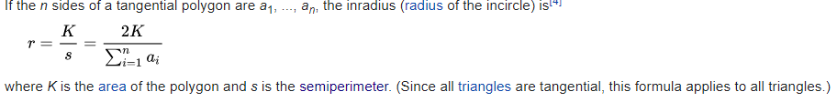

# Semiperimeter

the semiperimeter of a polygon is half its perimeter

Area of a triangle



The circumradius R of a triangle

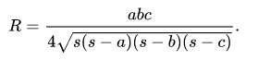

The inradius is

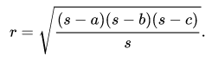

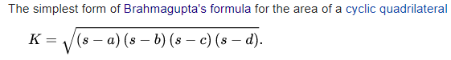

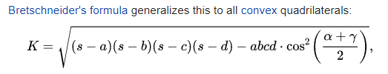

in which alpha and gamma are two opposite angles.

# Delaunay triangulation

Delaunay triangulation (also known as a Delone triangulation) for a given set P of discrete points in a plane is a triangulation DT(P) such that no point in P is inside the circumcircle of any triangle in DT(P). Delaunay triangulations maximize the minimum angle of all the angles of the triangles in the triangulation.

The circumcenters of Delaunay triangles are the vertices of the Voronoi diagram. In the 2D case, the Voronoi vertices are connected via edges, that can be derived from adjacency-relationships of the Delaunay triangles: If two triangles share an edge in the Delaunay triangulation, their circumcenters are to be connected with an edge in the Voronoi tesselation.

* The union of all simplices in the triangulation is the convex hull of the points.
* The Delaunay triangulation contains *O*(*n^*⌈*d*/ 2⌉) simplices
* In the plane (d = 2), if there are b vertices on the convex hull, then any triangulation of the points has at most 2n − 2 − b triangles, plus one exterior face
* If a circle passing through two of the input points doesn't contain any other input points in its interior, then the segment connecting the two points is an edge of a Delaunay triangulation of the given points.
* The closest neighbor b to any point p is on an edge bp in the Delaunay triangulation since the nearest neighbor graph is a subgraph of the Delaunay triangulation.
* The Delaunay triangulation is a geometric spanner: In the plane (d = 2), the shortest path between two vertices, along Delaunay edges, is known to be no longer than times the Euclidean distance between them
* The Euclidean minimum spanning tree of a set of points is a subset of the Delaunay triangulation of the same points, and this can be exploited to compute it efficiently.
* every edge not in a Delaunay triangulation is also not in any EMST